**1.18 Automate a Web Application.**

DESCRIPTION

**Project Objective:**

As a Full Stack Developer, you have to build an automation script that automated the basic functionalities like registration and login.

**Code in Eclipse with console**

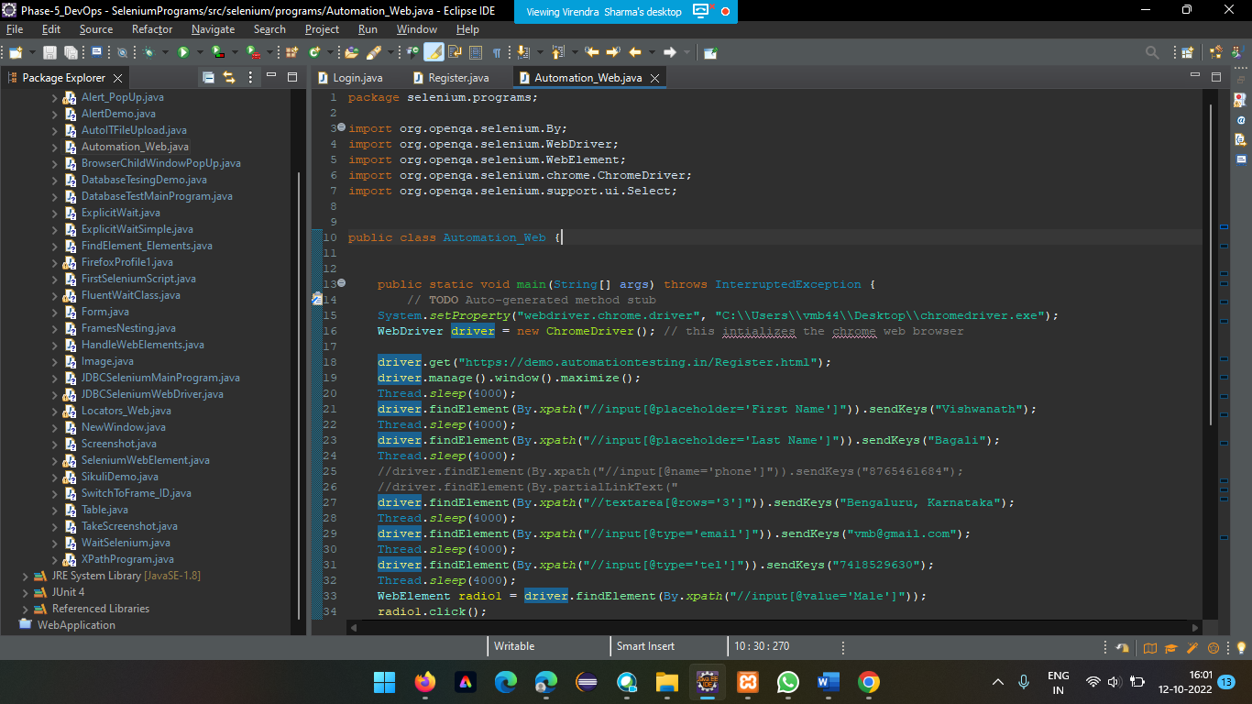

**Output of Automation Demo site (Screenshot)**

